DSA0504-Query processing for Data Science Name: Sahasra V
Reg no:192424234

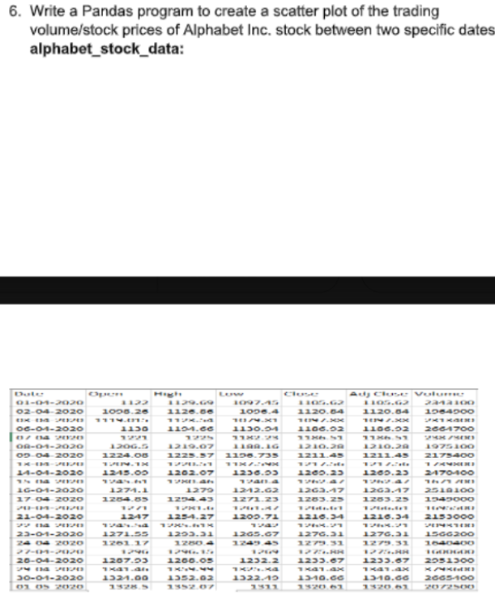

Aim
To create a scatter plot showing the relationship between the trading volume and stock prices (Close price) of Alphabet Inc. stock between two specific dates using the Pandas library.

Algorithm
- Import Pandas and Matplotlib libraries.
- Read the alphabet_stock_data.csv file into a DataFrame.
- Convert the Date column to datetime format and filter the required date range.
- Plot a scatter graph using Volume on the X-axis and Close on the Y-axis.
- Display the scatter plot with title and axis labels.
CODE:
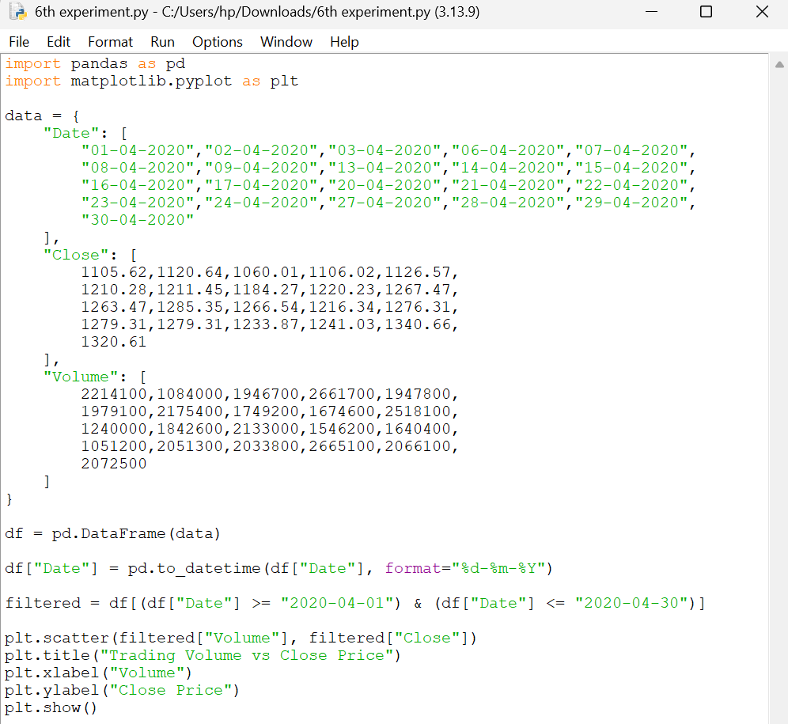

OUTPUT
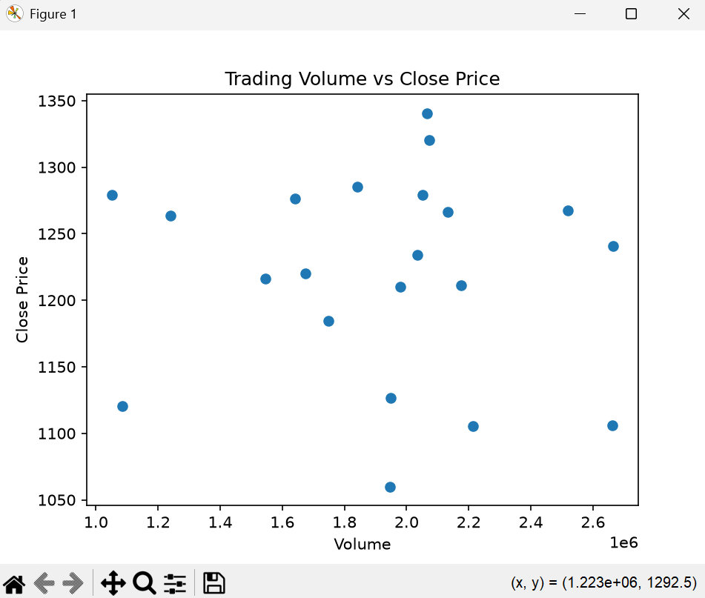

RESULT:
A scatter plot is generated showing the relationship between the trading volume and the closing stock price of Alphabet Inc. for the selected date range (01-04-2020 to 30-04-2020).

Question 7: Create a Pivot Table and Find the Maximum and Minimum Sale Value

Aim
To create a pivot table and determine the maximum and minimum sale value of each item using Pandas.

Algorithm
- Import the Pandas library.
- Create the sales dataset.
- Calculate the sale value (Units × Unit Price).
- Create a pivot table using Item as the index with max and min aggregation.
- Display the pivot table.

CODE:
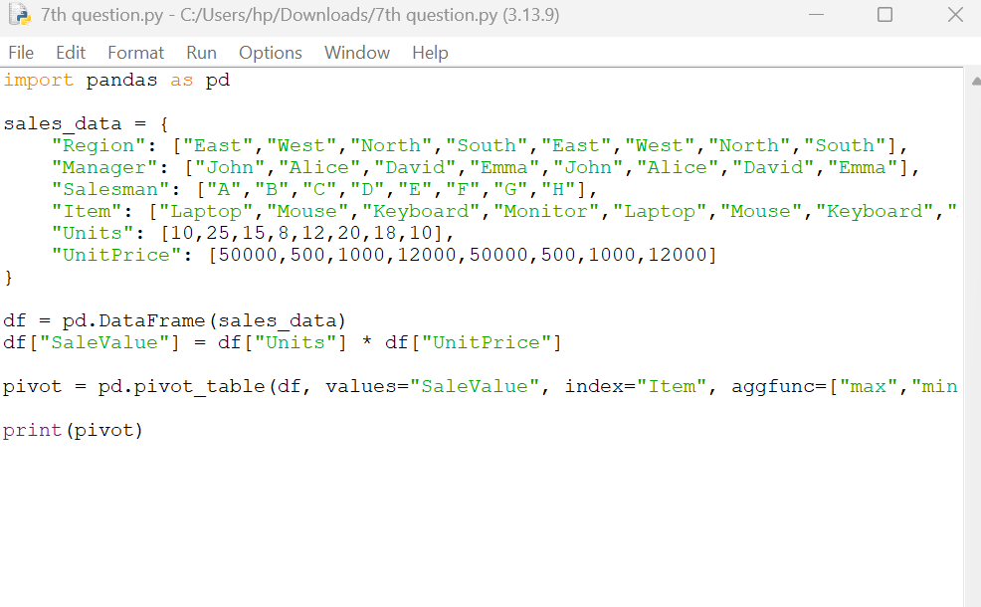
OUTPUT:
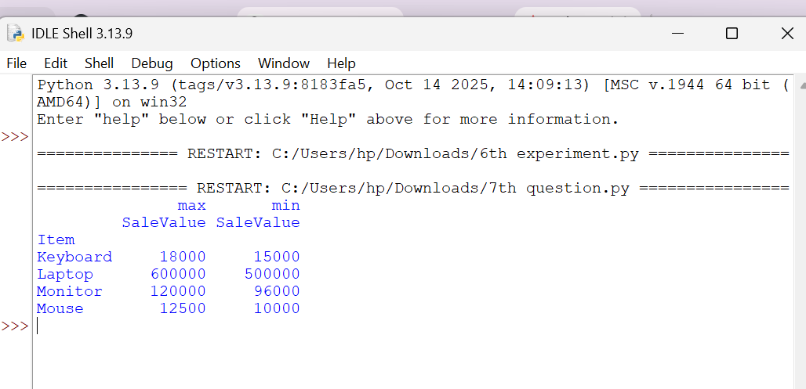

Result
The pivot table was successfully created, displaying the maximum and minimum sale value for each item.

Question 8: Create a Pivot Table and Find the Item-wise Unit Sold

Aim
To create a pivot table and calculate the total units sold for each item using Pandas.

Algorithm
- Import the Pandas library.
- Create the sales dataset.
- Create a pivot table with Item as the index.
- Sum the Units sold for each item.
- Display the pivot table.
CODE:
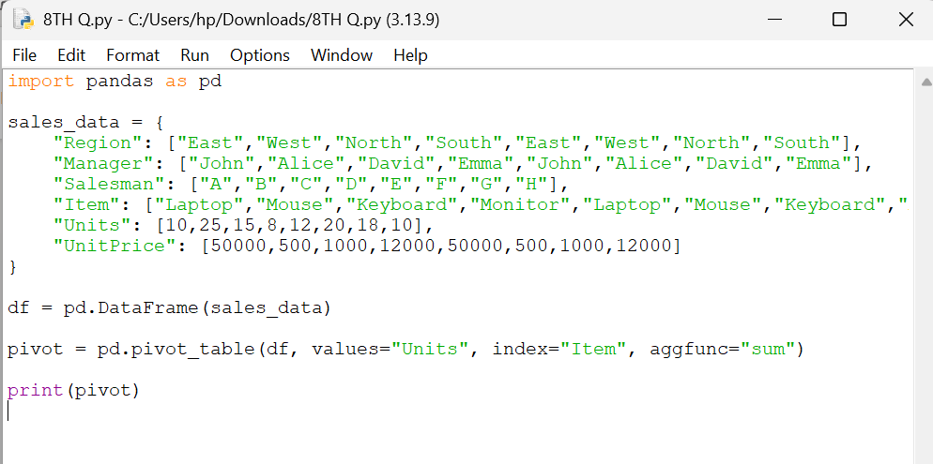

OUPUT:
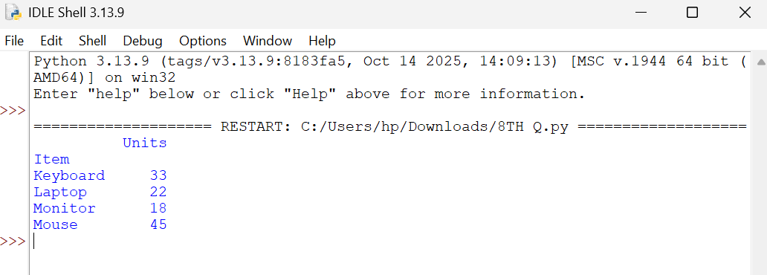

Result
The pivot table was successfully created, showing the total units sold for each item.

Question 9: Create a Pivot Table and Find the Total Sale Amount Region-wise, Manager-wise, and Salesman-wise

Aim
To create a pivot table and calculate the total sale amount based on region, manager, and salesman using Pandas.

Algorithm
- Import the Pandas library.
- Create the sales dataset.
- Calculate the sale value (Units × Unit Price).
- Create a pivot table using Region, Manager, and Salesman as the index.
- Display the total sale amount.
CODE:
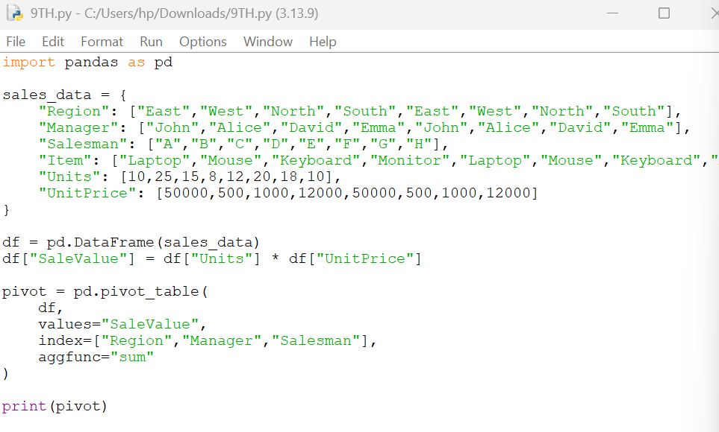
OUTPUT
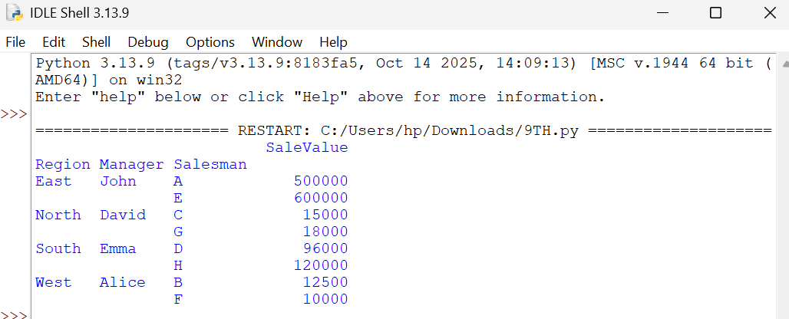

Result
The pivot table was successfully created, showing the total sale amount region-wise, manager-wise, and salesman-wise.

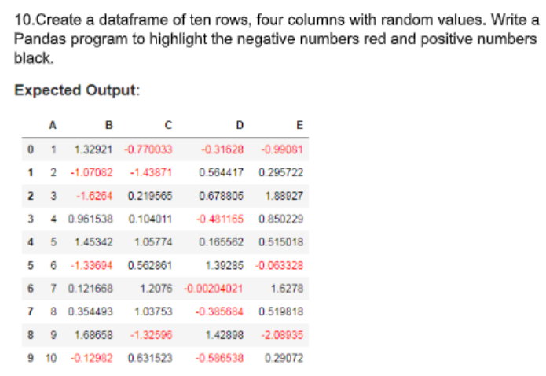

Aim
To create a DataFrame with 10 rows and 4 columns containing random values and highlight negative numbers in red and positive numbers in black using Pandas styling.

Algorithm
- Import the Pandas and NumPy libraries.
- Generate a DataFrame of random values with 10 rows and 4 columns.
- Create a function to assign red color for negative values and black color for positive values.
- Apply the styling function to the DataFrame.
- Display the styled DataFrame.
CODE:
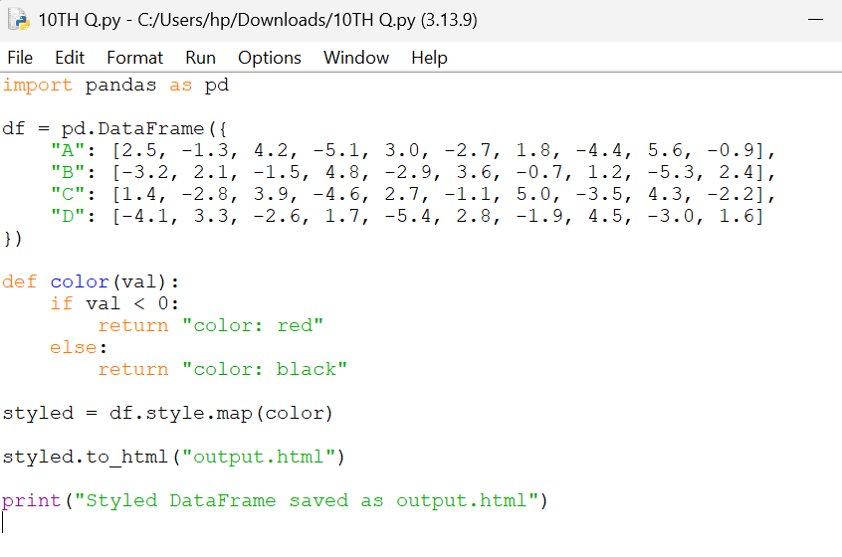
OUTPUT:
